

CS789 Encryption/Decryption

Symmetric and Asymmetric Enc/Dec

Digvijay Singh | Cryptography | 12/13/2021

# ElGAMAl

I have created this encryption algorithm in three steps –

* For Entire Simulation between Alice and Bob Enter 1
* To encrypt a message and generate a public key Enter 2
* To decrypt a message Enter 3
* To Generate Bob Public Key Enter 4

ELGAML EVE ATTACK

# RSA

I have created this encryption algorithm in three steps –

* For Entire Simulation between Alice and Bob Enter 1
* To encrypt a message and generate a public key Enter 2
* To decrypt a message Enter 3

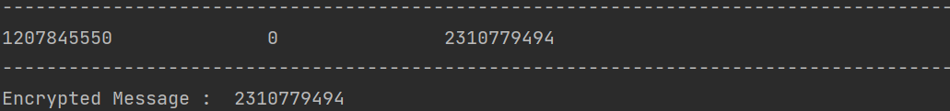

RSA EVE ATTACK

